|  |  |  |  |
| --- | --- | --- | --- |
| Group Member | Name | ERP | Roles [Select from: BI Analyst, Feedback Colleague, Stakeholder] |
| 1 | Hajra Abdul Hai | 14893 | For dashboard Phase1: Feedback Colleague  For dashboard Phase2: BI Analyst |
| 2 | Marium Jamal | 14881 | For dashboard Phase1: BI Analyst  For dashboard Phase2: Feedback Colleague |

Note: After identifying potential flaws in both the phases of dashboard, we worked as a team to design our final dashboard output.

Instructions: Dear students, the following is a complicated activity so please make any assumptions yourself to solve the steps below. There is not much need to ask me as I can give recommendations only and there probably will not be any fixed response to any query. So, make assumptions and list them below.

**Assumptions taken by the group in solving this document:**

* Problems identified was primarily based on the given dataset.

**Launch Phase**

**Step 1:** Background knowledge of Supply Chain (bulleted list): *You can decide to fill-up the background knowledge template first, and then extract the useful information from there to enter here. Remember that previously successful case studies are important. You can update this section later on by returning from any of the future steps.*

* A supply chain is an entire system of producing & delivering a product or service, from the very beginning stage of sourcing the raw materials to the final delivery of the product or service to end-users.
* The importance of clearly laying out the supply chain is that it helps a company define its own market and decide where it wants to be in the future.
* The supply chain enables a company to understand others that are involved in each of the stages, and thereby provides some insights on the attractiveness/competitiveness in industries the company might want to enter in the future.
* Process involved in the supply chain of generic industry is as follows:

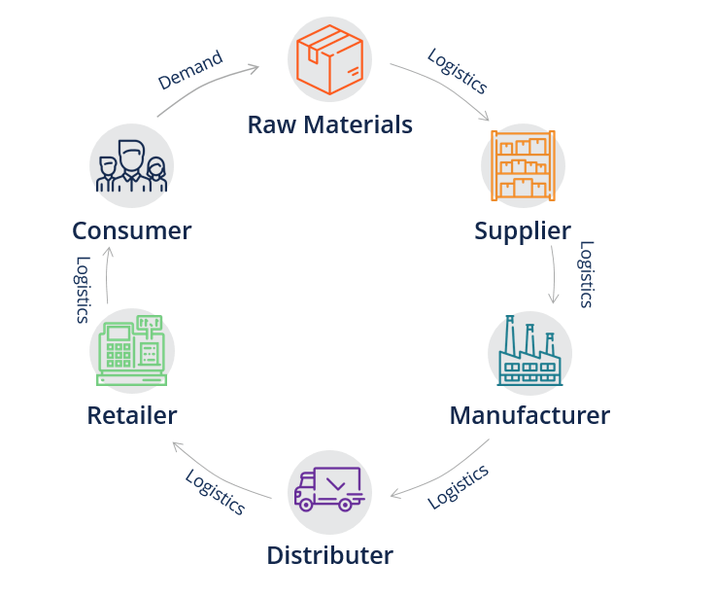

* Procedure involved in the supply chain of an ecommerce is as follows:

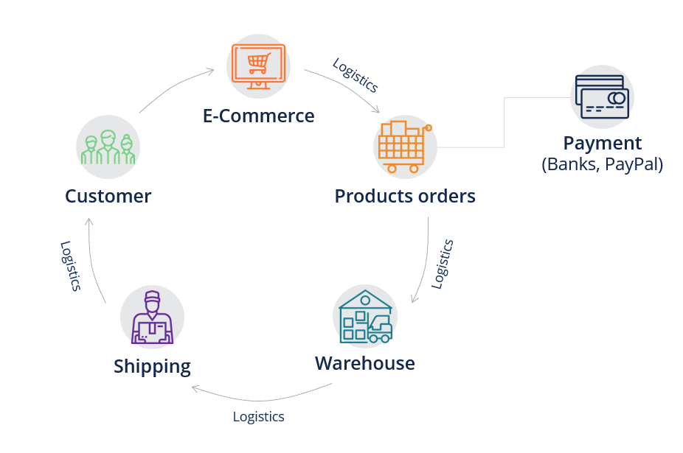

* The value a supply chain generates is the difference between what the final product is worth to the customer and the cost of supply chain incurs in filling the customer's request. For most commercial supply chains, value will be strongly correlated with supply chain profitability i.e. the difference between the revenue generated from the customer and the overall cost across the supply chain.
* The supply chain process occurs in two ways, Cycle View and Push/Pull view - Pull process are initiated by a customer order, whereas push process are initiated and performed in anticipation of customer orders; whereas, cycle view of Supply chain process includes,
* Customer order cycle
* Replenishment cycle
* Manufacturing cycle
* Procurement cycle
* Supply chain management tools and techniques are seen as mechanisms that will allow a firm to respond to the environmental changes. By working more collaboratively with supply chain partners, a firm can better understand changes in customer requirements and respond more quickly to the changes.
* Any supply chains success is closely linked to the appropriate use of transportation.
* A key aspect of supply chain management is the ability to make strategic decisions quickly based on accurate data, Without information relayed at right time to the right place, there are no purchase orders, no shipment managers and no payments and the supply chain shuts down.
* The supply chain information systems rely on either EDI (Electronic Data Interchange) or the Internet to transmit information within the supply chain.
* Healthcare supply chain management is unique because each stakeholder has their own interests to protect i.e. providers may want to use a specific product because they were trained with it, whereas hospital executives aim to purchase the most affordable quality items.
* Almost all hospitals(p8%) and supply chain leaders believe supply chain optimization improves hospital margins; 60 % believe supply chain analytcs positively impact care quality.

**Step 2:** Determine the stakeholder-problem matrix: *What are the supply chain problems being faced by this industry and who are the stakeholders who want this problem solved (add more columns/rows is desired)*

|  |  |  |
| --- | --- | --- |
| Stakeholder | Problems | Problems |
| Logistics Manager | Why was there a sudden increase in freight cost from 2009 to 2011? | Why no. of delays were more in 2009 than in 2011? Even though freight cost was more in 2011. |
| Quality Assurance Manager | Increase in pack price does not guarantee high quality. Why? | - |
| Finance Manager | What are some of the hidden costs in pharmaceutical supply chain industry that are not taken into consideration? | - |

**Step 3:** Start Small: Select the problem you want to solve and mention it below: *if you think you can solve all these problems for all the stakeholders through one story, that is also acceptable. Otherwise, select only a single problem and mention below.*

* Problem 1: Why was there a sudden increase in freight cost from 2009 to 2011?
* Problem 2: Why no. of delays were more in 2009 than in 2011? Even though freight cost was more in 2011. (Was taken into consideration after getting feedback in step 8)

**Step 4:** Problem Detail (bulleted list): *Write down the details of the problem identified in matrix above. The purpose here is to clear your own mind about what is the exact issue with a little bit of its detail.*

* Problem 1: Why was there a sudden increase in freight cost from 2009 to 2011?

This problem focuses on the fact that a huge surge was observed in the freight cost from 2009 to 2011. Freight Cost is a combination of multiple costs based on the requirements of variety of products during the transportation. Hence, in order to find a best possible soultion to get a reasonable figure for freight cost, the potential stakeholders want to identify the reasons which led to this increase in freight cost.

* Problem 2: Why no. of delays were more in 2009 than in 2011? Even though freight cost was more in 2011.

After analysing the reasons for problem 1, it was observed that with the increase in freight cost in 2011, there is a decrease in no. of delays. This relation was quite ambiguous with respect to general standard. Therefore, the potential stakeholders want deep drill-down on the data in order to get a valid reasoning for the above stated problem of delays.

* Problem 3: Increase in Pack price does not guarantee high quality. Why?

Every touchpoint with an end user needs to be focused on providing excellent products and services. Quality and speed are becoming as important as pricing when it comes to purchasing goods. With a severe increase in prices, consumers want retail goods immediately and online goods within a few days, products must meet the quality requirements.

* Problem 4: What are some of the hidden costs in pharmaceutical supply chain industry that are not taken into consideration?

Challenge that healthcare providers face is the hidden costs of every product. Most providers have historically just looked at the product cost and the shipping cost. But there are additional expenses, such as inventory holding. Providers need to plan their budget around total landed supply costs. They need to be aware of the losses they will incur from the unavoidable aspect of expired products and excess supplies. They need to look at product standards and purchase price variance. This is where quality healthcare software comes in. Providers can start taking a more holistic approach to pricing their products, including the costs associated with moving and managing supplies. This means product utilization, special deliveries, internal distribution, and much more.

**Step 5:** Your Solution (bulleted list): *What is your solution? How will it solve the problem? It is better to specifically mention it.*

* In order to solve problem 1 stated above, it is important for the concerned authorities to take into consideration the reasons that led to this problem such as for problem 1, we are going to focus on all potential dimensions that are dependent on freight cost such as the shipment mode, product quantity and storage cost.
* In order to solve problem 2 mentioned above, we are going to look on the same attributes that were highlighted in problem 1 solution along with the major focus on delays(recorded delivery date – Scheduled delivery date).

**Step 6:** Identify potential metrics/KPIs (bulleted list): *This needs to be done from your previous experience and background knowledge. Consult:* [*https://www.datapine.com/kpi-examples-and-templates/*](https://www.datapine.com/kpi-examples-and-templates/)

* Average Freight Cost
* On-time Deliveries
* Pack Price
* Average Delays

**Step 7:** Potential data that will become available to you (bulleted list): *In your case, the data is already there so you can start using it immediately.*

* (Dataset was already provided)

**Step 8:** The first solution: BI Blueprint on paper with Story: *Paste the story below, e.g., paste the pictures of your paperwork in sequence. Also write the feedback of your colleague as a bulleted list and the changes made. Record an audio file with the story and save it as “First.Solution.Audio”. Upload this on LMS.*

Feedback of colleague:

* Headings should be concise
* First page of the dash board should also contain some graphs and not just gauges
* It is recommended that the time slicer should have scroll bar instead of check box.
* For charts & gauges, focus on the dimensions that are relevant to the chosen problem.
* Problem 2 about delays can also be solved along with problem 1 in the same dash board.

Changes made:

* In the first page of the dash board the size of the gauges were reduced and graphs such as pie chart, line graph and a bar graph were added.
* Headings were rephrased
* More charts were added to analyze problem 2.

Blueprint pictures (paste below in sequence):

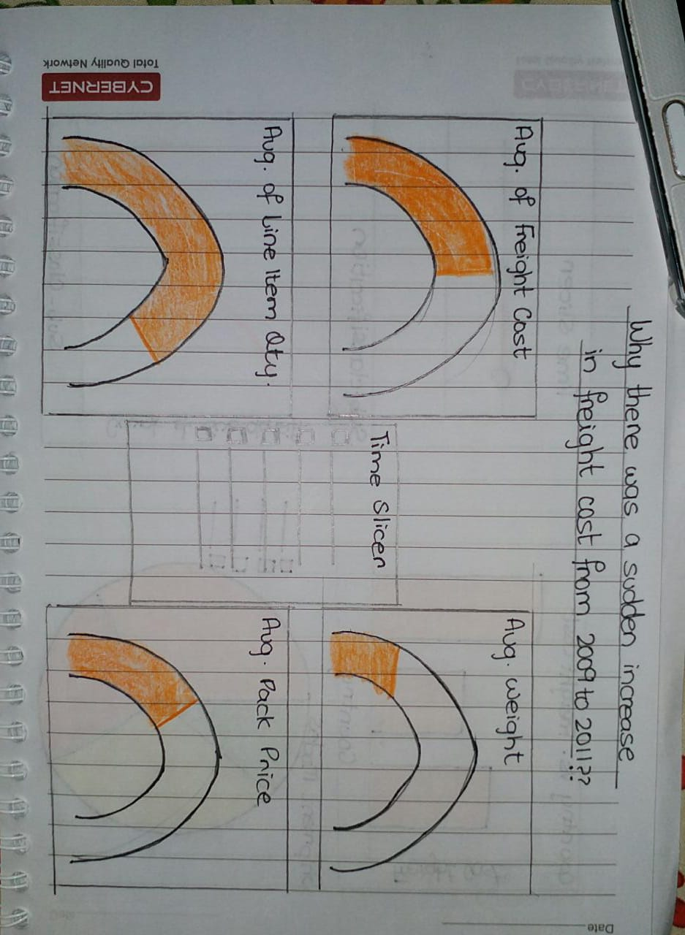

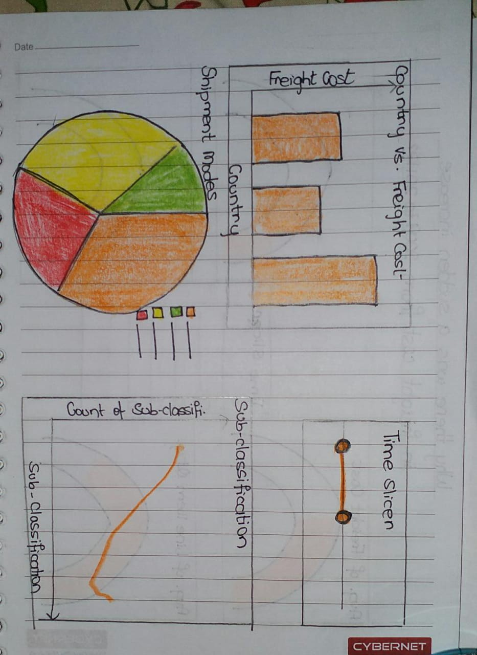

**Wrangle Phase**

**Step 9:** Draw the pipeline of wrangling + analytics on paper: *Paste the snapshots below with explanations.*

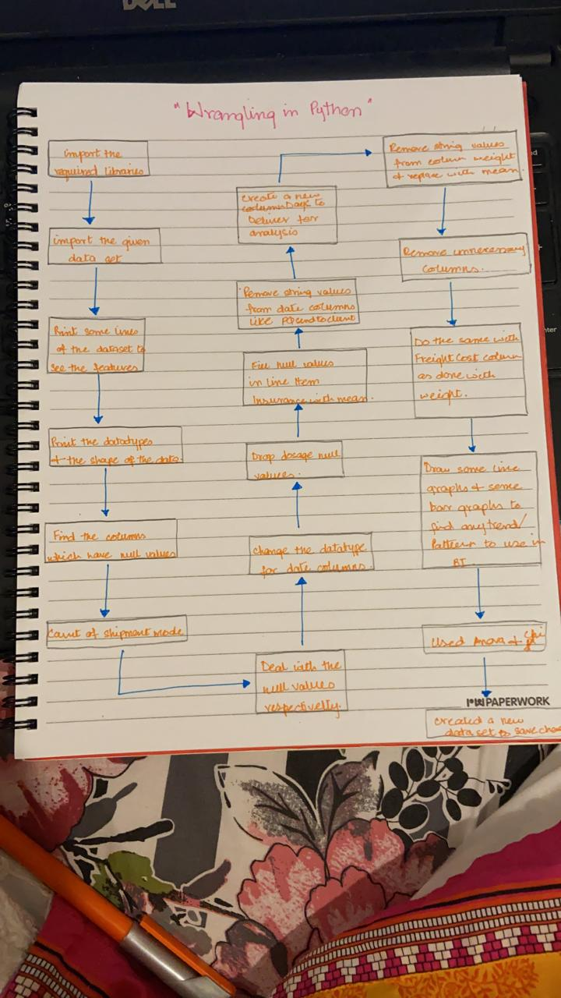

**Step 10:** Based on your stakeholder matrix above, make an educated guess about the single-server or multi-server application and draw that on paper: *Paste the snapshots below with explanations.*

*<Too ambiguous to understand the meaning of this requirement>*

**Step 11:** Wrangle the data and interpret the results: *Submit the notebook with interpretations within – focus only on those interpretations which have a relationship with BI outputs (as explained in class). Also try to make a template. The more wrangling you do, the more marks you will get.*

* *(Attached)*

**Brainstorm Phase**

**Step 12:** Modify the pipeline in Step 8 above (if needed): *Paste the story below, e.g., paste the pictures of your paperwork in sequence. Also write the feedback of your colleague as a bulleted list and the changes made. Record an audio file with the story and save it as “Second.Solution.Audio”. Upload this on LMS.*

Feedback of colleague:

* Instead of focusing on days to deliver, it is better to calculate the delays directly in PowerBI and solve accordingly.
* Both scorecards and gauge meters should primarily focus on the KPIs of the problems.
* ‘Days to Deliver’ slicer must be replaced with ‘Delays’ slicer.

Changes made:

* No. of delays were calculated using PowerBI measure functionality.
* Freight Cost by Days to Deliver chart was removed.
* Guages focusing on delays and freight cost were kept only.
* Scorecards displaying the multiple variants of delays were placed inline.
* To get an idea of quantity, graph of sub-classification was added because dimension ‘Line Item Qty’ was litte ambiguous to understand.
* ‘Days to Deliver’ slicer was replaced with ‘Delays’ slicer.

Blueprint pictures (paste below in sequence):

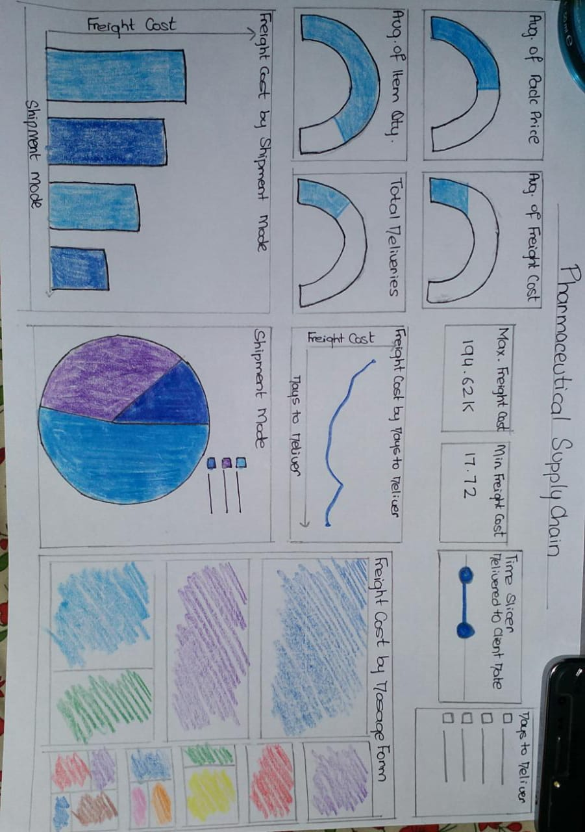

**Dash Phase**

**Step 13:** Which dashboard type are you implementing (Strategic, Operational, Analytics, Tactical): *Mention below and justify:*

* The type of dashboard we are going to implement is Analytics because analytical dashboard is used to analyze large volumes of data to allow users to investigate trends and discover insights and are main goal is to identify the potential insights/reasons in order to solve our problem. Also, this type of dashboard contains infrequent data and our chosen dataset is also not updated frequently*.*

**Step 14:** Implement on PowerBI and paste all dashboards below: *Also write the feedback of your colleague as a bulleted list and the changes made. Record an audio file with the story and save it as “Third.Solution.Audio”. Upload this on LMS. Here, you must focus 100% on how this story is solving the problem mentioned at the top of the document.*

Feedback of colleague:

* Final dashboard provides a complete reasoning of both the problems stated above with a perfect selection of charts and score cards.
* Overall theme selected was very attractive.

Changes made:

* Not needed.

Blueprint pictures (paste below in sequence):

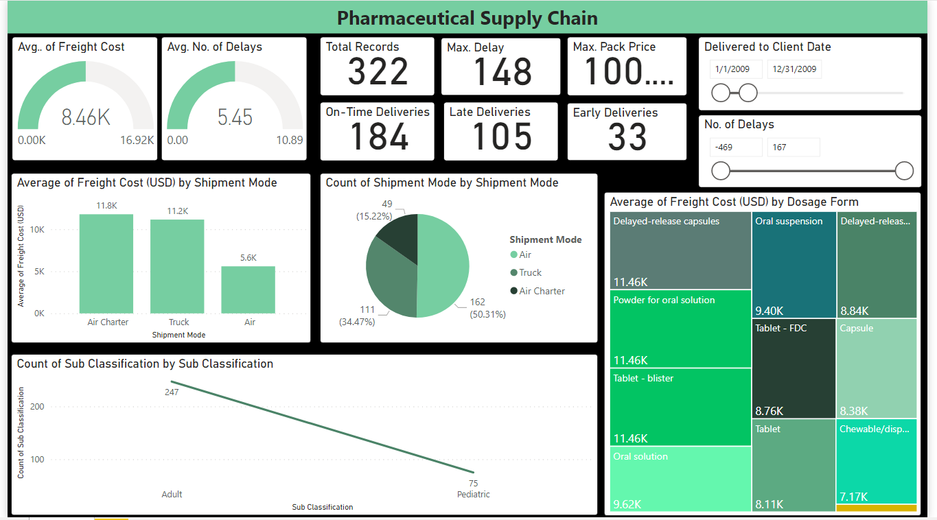

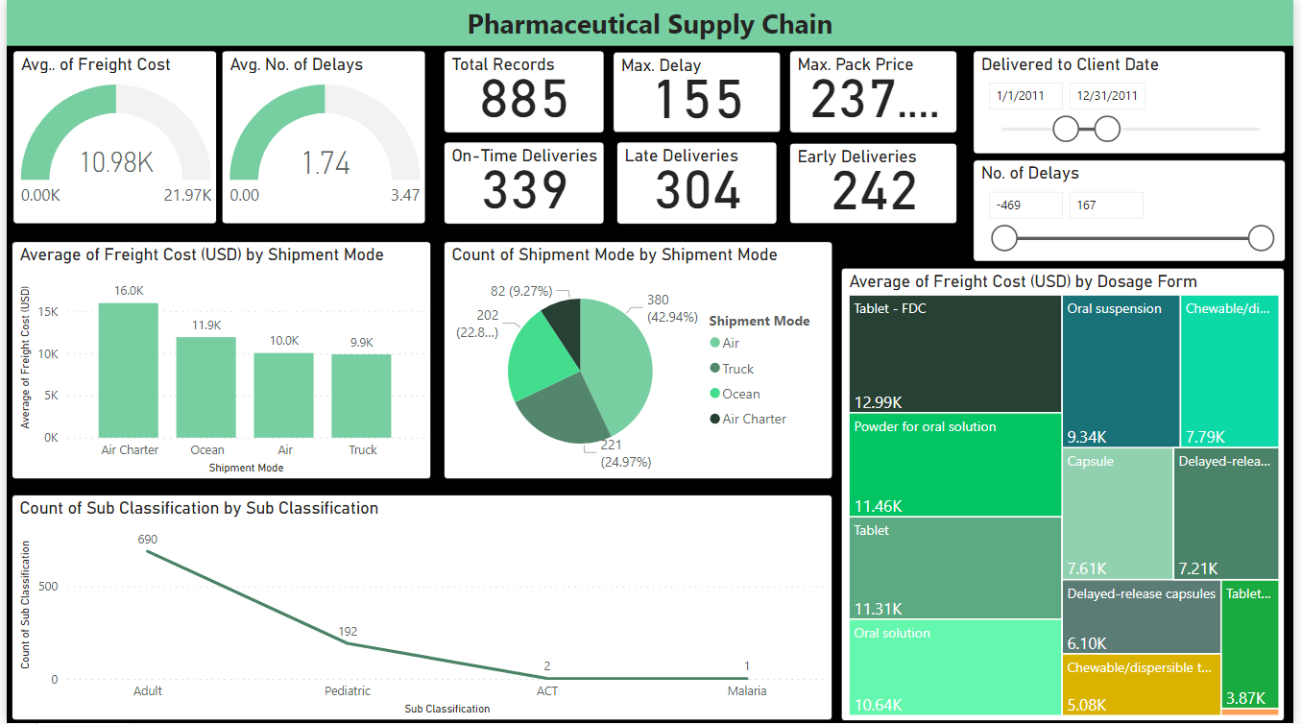

Link: <https://app.powerbi.com/view?r=eyJrIjoiODI0OWUzNGMtZWUyMi00MTQ3LWEzMDctOTljMjE0ZmVmNGQ4IiwidCI6ImZlZTNiOTE2LTAxYzEtNDk4Ny1hNjQ2LWUxOTM0MzJiOWVhYSIsImMiOjl9>

**Step 15:** What are the take-aways of your group from the above exercise. Mention pros and cons.

Pros:

* Discovered new features of PowerBi such as creation of new column w.r.t our own calculated measure.
* Improved our analytical skills by identifying the trends and patterns from a completely diverse field of supply chain.
* Working as a team helped us in improving our flaws collectively as a team.

Cons:

* Dataset provided was ambiguous and a little bit difficult to understand.

Outputs Required on LMS:

* Word and PDF versions of this document
* First.Solution.Audio, Second.Solution.Audio and Third.Solution.Audio
* PowerBI project
* Wrangling notebook with interpretations